**Lab3 Assignment**

**Prudhvi Nalluri**

**16163411**

In this I developed a web service to Create, Upload, Retrieve, Delete the data in the Hbase by using the glassfish server and restful service. The data collected in the lab2, which consists of humidity, temperature, Date, Location, Accelometer using sensortag is used here to upload into the Hbase table.

This is the dynamic web project created and deployed into the glassfish.

Created a glassfish server and restful service.

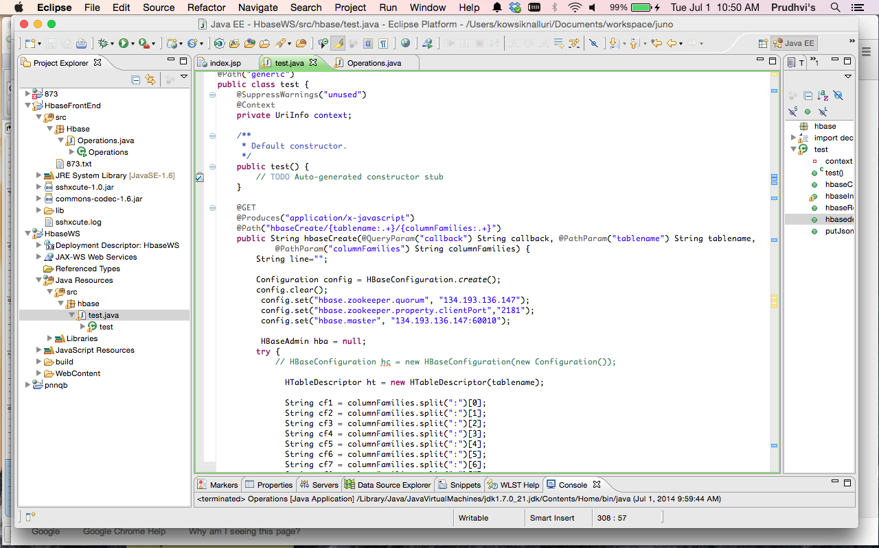

**Uploading the Data into Hbase using Web Service:**

After deploying the war file in the glassfish

Created a table “lab3prudhvi” in Hbase using the web service.

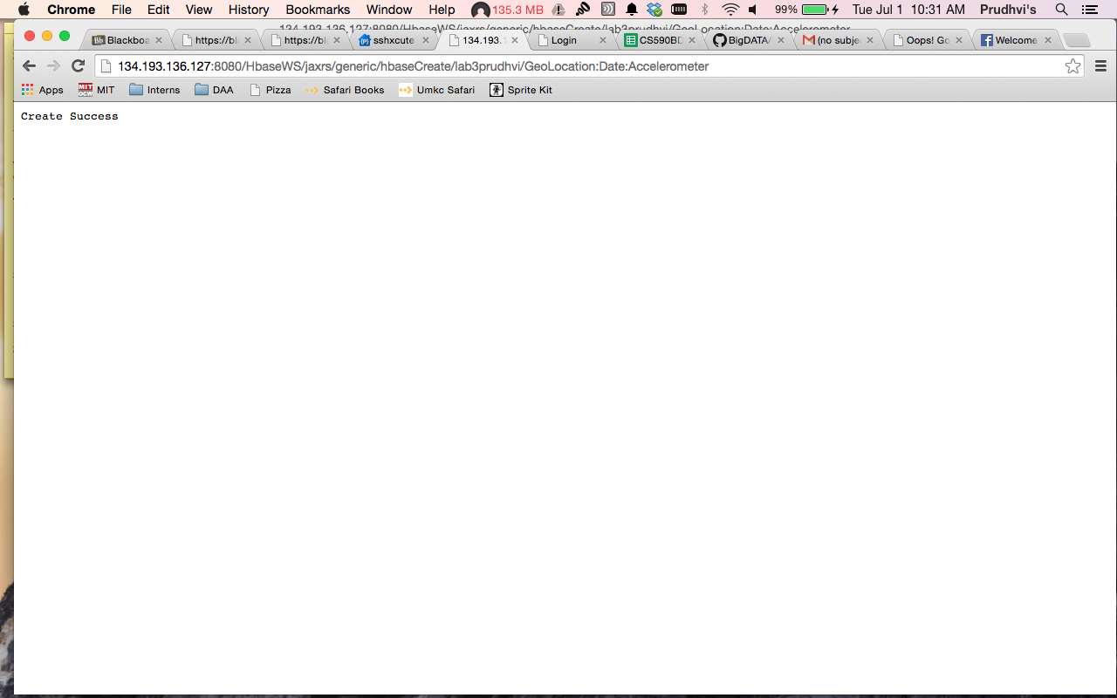

“lab3prudhvi” Table in Hbase

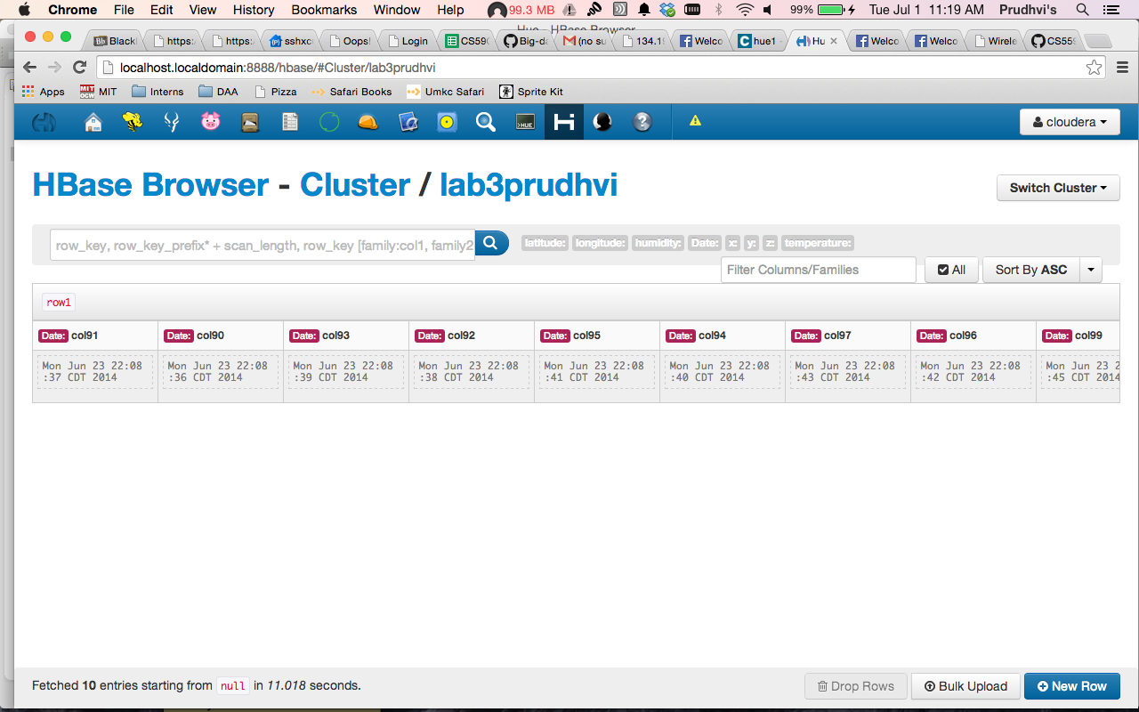

Inserted the data in the sensor tag txt file into the Hbase using web service

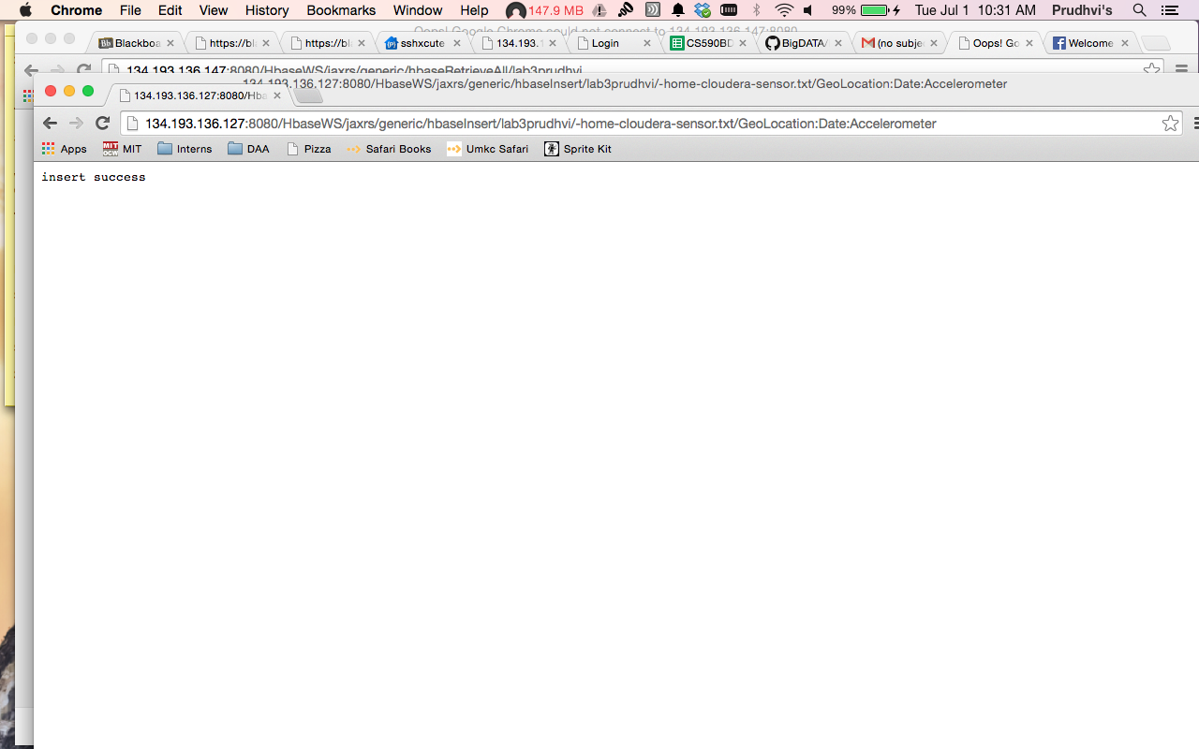

Retrieving the data from the Hbase using web service.

